广州二测读后续写学案

**Outside the Box**

The Harvestfest contest was falling on Friday and everyone in school was talking about it. All the students would show up in their self-made costumes(装扮)and a winner would be chosen by the principal.

“Do you have your costume for the Harvestfest contest?"Alice asked."I'm going as a chocolate bar. My mom and I have been working on it all week.”

“Yeah, I have a costume,”said Jordan Eastman, popping up the two front wheels of his wheelchair as he waited for his dad to pick him up.“But it's boring.”

“Why? What is it?”Alice asked.

“MaxMag the superhero, but Danny, Tom and Izzy are all going as MaxMag too.” Jordan shook his head.“That's too many to stand a chance at winning the contest.”He waved to his dad, who had just pulled up in front of the school.

Jordan rolled his wheelchair toward his dad, and Alice walked with him to the minivan(小货车).

“Maybe you should go as something else.”

“The contest is Friday night.”Jordan sighed.“It's too late to change costumes.”

“Jordan, you have to think outside the box. Look around your house and see what you have. There's hidden potential in everyday items."She took a sip of her drink, and told Jordan that her chocolate-bar costume was made from old fabric her mom had lying around and recycled plastics.

On his way home, Jordan was quiet. He kept thinking about Alice's words: Think outside the box. There's hidden potential in everyday items. When he got home, he found his mum handling with some wooden pieces. She was putting a new desk together. On top of the desk was the huge empty cardboard box the pieces had come in. Mom smiled at Jordan, pointing at the desk,“What do you think?”

1. Read for Settings:

**where**

**when**

**what**

**why**

**who**

1. **Read for plots:**

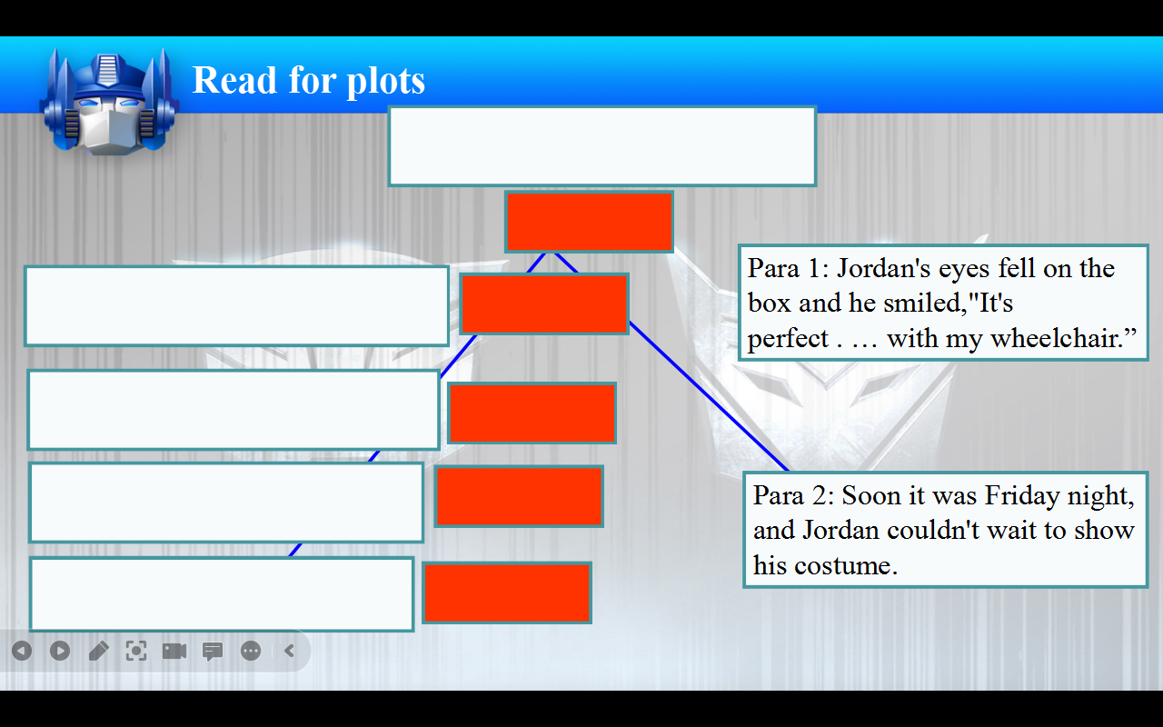

1. **Read for conflict**

Conflicts Possible endings

__________________________ _______________________

__________________________ _______________________

__________________________ _______________________

__________________________ _______________________

__________________________ _______________________

__________________________ _______________________

__________________________ _______________________

1. **Read for clues**

|  |  |
| --- | --- |
| Clue | Foreshadowing |
|  |  |

1. **Predict for writing**

Para 1: Jordan's eyes fell on the box and he smiled,"It's perfect . … with my wheelchair.”

衔接句1：_______________________________________________

情节推进（心理）：________________________________________

情节推进（动作）：________________________________________

衔接句2：________________________________________________

Para 2: Soon it was Friday night, and Jordan couldn't wait to show his costume.

1. 衔接句3：_______________________________________________

2. 情节推进（心理\动作）：____________________________________

3. 结尾：___________________________________________________

4. 主题升华：

___________________________________________________________ ___________________________________________________________

**相似“成长”类续写考题（2023深圳一模）：**

Today was Community Service Day at school. Maya’s class was going to make cards for the seniors living in a nursing home. It was also the first day Maya would be wearing her leg brace (腿支架) to school, which was designed to help her walk more steadily and smoothly.

It was a cold autumn morning. Maya looked down, feeling embarrassed. To make it lovelier, she had delicately decorated the brace with pretty butterfly patterns. Still, she was unsure about others‘ reaction. All morning at school, kids kept glancing at her brace. To her relief, they didn’t say anything.

In the classroom, Maya was drawing little green buds (芽) and pretty flowers when her friend Samir came over and sat by her. She felt his eyes fixed on her brace and heard him asking, “What’s that for?” Not knowing what to say, Maya pretended she didn’t hear him. After a few seconds of awkwardness, she glanced back at him, and found that he looked a little sad.

After lunch, the class set off. The nursing home was on a small hill and all of them walked there happily along the path. Maya found that the brace did make it easier for her to walk up.

Maya and Samir were paired up with a lady who was 83 years old. There at the end of the hall in a wheelchair, with a big smile on her face, sat the lady, wearing a pink coat, with red lipstick and beautiful earrings. She looked bright and full of life. Moving flexibly and fast towards Maya and Samir, she greeted first. “I’m Joan,” she said cheerfully, “Glad to meet you.”

Maya and Samir handed her the cards they made. Joan looked at Samir’s card carefully and spoke with admiration, “You’ve written a poem! That’s so artistic!” Samir’s face reddened with shyness. Then Joan turned to Maya’s picture. “The first flowers of spring!” she cried in delight. “You really have a gift for using colour!” she said. Clearly, Joan’s praise added great power into Maya.